“Never Shall I Forget”:
IN-CLASS HOLOCAUST MEMORIAL MUSEUM

Use this booklet to record your responses to our Holocaust Museum. At each exhibit, jot down notes, key words, etc. that accurately describe what you see and how you feel. Compile your answers as well as your final narrative/poem (directions in exhibit 7). Your response as well as your narrative/poem will be due in

Exhibit 1: Timeline of the Holocaust

1. What methods of dehumanization did the Nazis use?

2. What is your emotional reaction to the exhibit?

3. Choose one subject (propaganda, experiments, concentration camps, etc.) from the timeline that interests. You will have an opportunity to research more about this subject in Exhibit #7

Exhibit 2: Propaganda

1. What do you find shocking or striking about this display? Why?

2. What image stood out the most to you why?

3. What is your emotional reaction to the exhibit?

Exhibit 3: Government Hatred
1. What did Himmler say that you found most shocking? Why?

2. How would you feel if your government spoke out against you and your family in this manner?

3. What is your emotional reaction to the exhibit?

Exhibit 4: Camps: A Virtual Tour

1. What do you find shocking or striking about this exhibit?
2. Which aspect of camp life is hardest for you to imagine?
3. What is your emotional reaction to this exhibit?

Exhibit 5: Personal interaction

Logon to http://www.ushmm.org/education/forstudents/ and select one of the areas of your own personal interest. Refer to the note you made for your interest at Exhibit 1 for your selection. If you’ve not yet visited Exhibit 1, just select one of the choices. Spend 10 surfing/exploring one of these areas from this webpage of your own choosing

1. What information did you find?

Exhibit 6: Film study
Select one of the two videos located on the website.
The first video- Eva Kor - Survivor of the Holocaust and Nazi Experiments on Twins (Eva Kor is a Holocaust survivor who endured the Dr. Josef Mengele's twin experiments at Auschwitz.)

The second video- Ben Dunlap: The life-long learner (Wofford College president Ben Dunlap tells the story of Sandor Teszler, a Hungarian Holocaust survivor who taught him about passionate living and lifelong learning.)

EEJ Focus Question: How did the survivor of The Holocaust overcome their anger and hatred?

Examples | Explanation
1. | 1.
2. | 2.
3. | 3.

Respond to the focus question in a paragraph. You must use the three examples/explanations in your response. Focus on embedding your examples seamlessly into your paragraph. Use a

Exhibit 7: Art in Response to the Holocaust

1. Which pieces of art impacted you the most? Why?

2. Respond emotionally to the exhibit.

Exhibit 8: Wall of Remembrance
After you finish the museum, come get a card of a Holocaust victim. Download the PDF below and determine whether she/he survived or perished.

1. Write down your victim’s name_______________
Now that you have completed your tour of our Holocaust Museum, respond to your victim of The Holocaust for your final response. Choose from the list below.

Name____________________________________ English 10
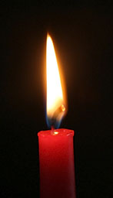

“Never Shall We Forget” Holocaust Museum Response Assignment
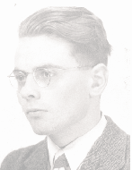
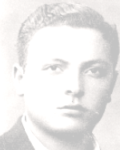
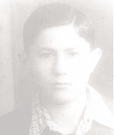
Now that you have completed your tour of our Holocaust Museum, choose a survivor or victim of the Holocaust from the “Wall of Remembrance” for your final response assignment.
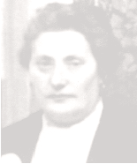
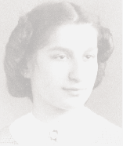

You may either:
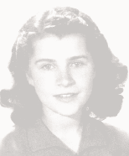
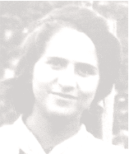
- Write a first-person narrative from the perspective of the person you chose that tells the story of their life. You must tell that person’s story, incorporating information you have learned from at least four of the museum exhibits. Your narrative must be two pages, typed.

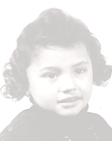
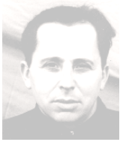
- Write a letter to the person you chose expressing your feelings about the Holocaust based on your responses to the museum exhibits. You must relate your responses to at least four of the museum exhibits to the experiences of the person you are writing to. Your letter must be two pages, typed.

